Connect AWS Linux instance from Linux machine
Instance launched
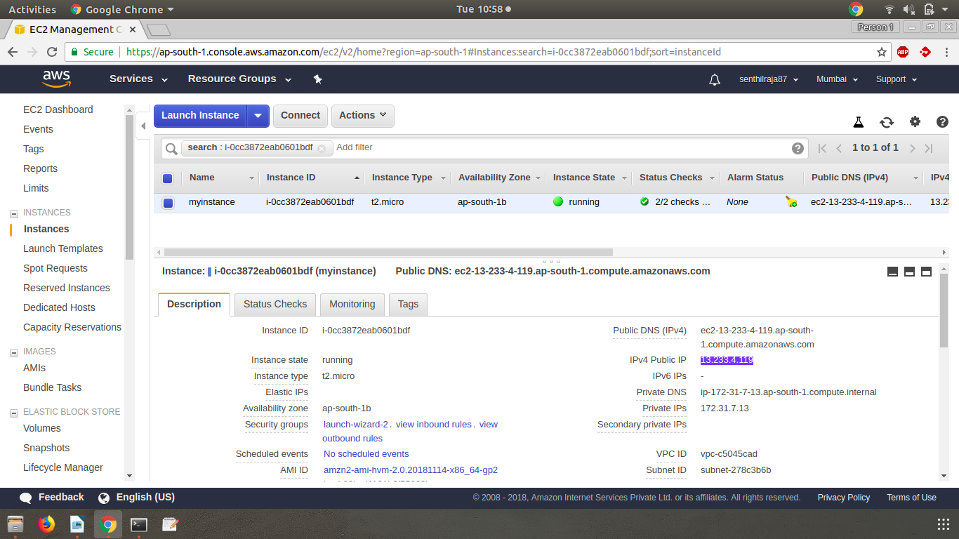
Intance Public IP: 13.233.4.119
User Name: ec2-user
pem file downloaded into local linux machine.
Step1: Open Terminal in linux machine

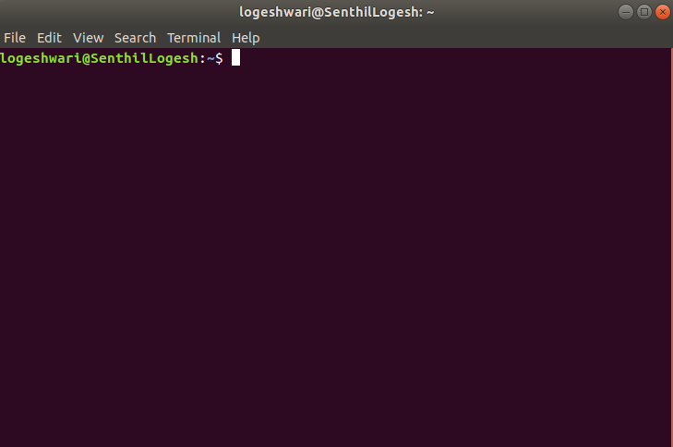

Step2: Goto pem file location
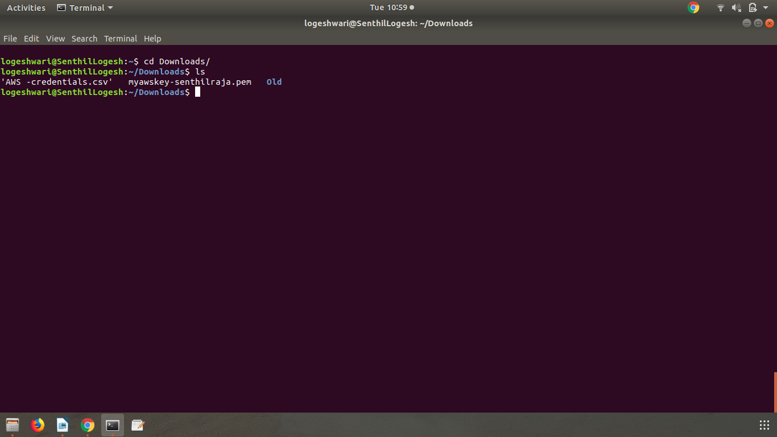

Step3: Now Connect our instace with below comment
ssh -i ‘pem file’ ‘username’@’instance-public-IP’
Ex: ssh -i myawskey-senthilraja.pem ec2-user@13.233.4.119

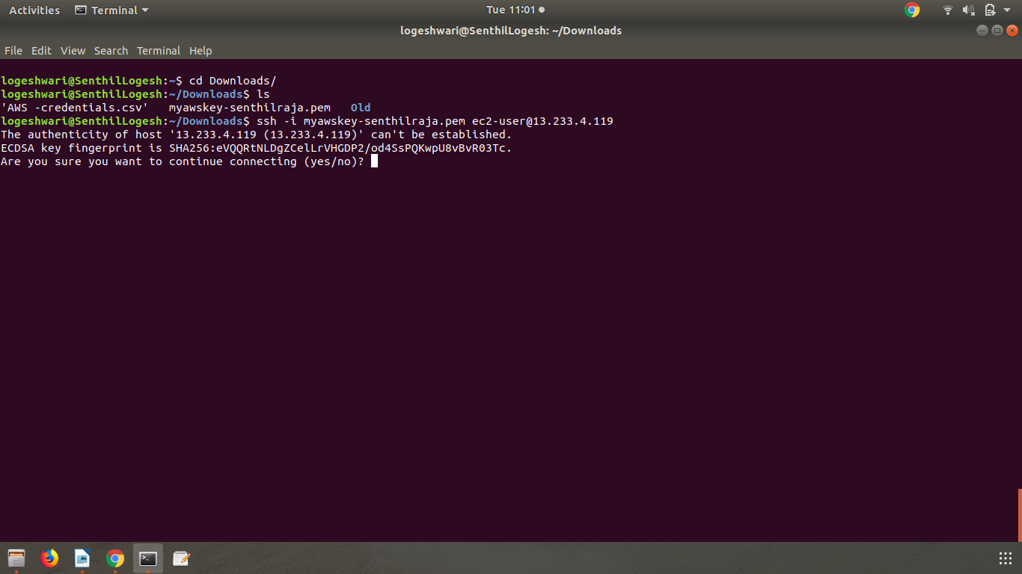

Type ‘Yes’ Now logged into instance.

